STUDENT Joseph Roper

SALFORD CITY COLLEGE | FUTURE SKILLS

BTEC National Extended Diploma in Creative Media Production

UNIT 72: COMPUTER GAME DESIGN

Unit 72 – Task 1

# Terrain

Game terrain can be described simply as the surface your player would traverse on in a game meaning the ground and environment of a game for example the sand dunes of world 2 in the super Mario game series. Most terrain in games is often similar for example you have the biomes in Minecraft and the worlds in the Mario game series which both contain a terrain with a forest, dessert, lava/hell and ice. These terrains can be related to the real world biomes but exaggerated making the player feel comfortable with the familiar environments yet awed in the fantasy of perhaps living in an ice kingdom while playing Minecraft or running through a forest and stomping on bad guys in one of the Mario games. The terrain of a game can affect a players experience entirely to make the game more frustrating or awe inspiring for example in Mario kart when racing up a snowy mountain the icy terrain can make your kart slip off of the level making the game more challenging.

[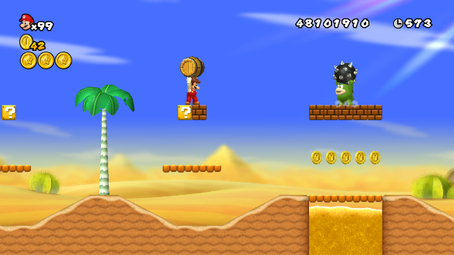](https://mario.fandom.com/wiki/World_2-2_(New_Super_Mario_Bros._Wii))[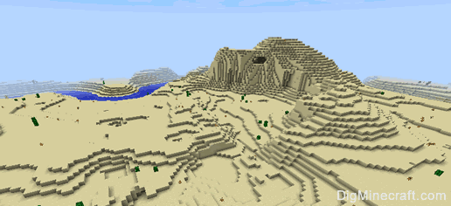](https://www.digminecraft.com/getting_started/biome_desert.php)

# Architecture

Architecture in games is the buildings you see while traversing through the levels or map of said game. Architecture resembles civilisation which in the terms of a video game means where you as a player can find NBC’s (Non-player characters) or other players if the game has online multiplayer for example with the game club penguin you can build and design your own igloo which other players can visit, the game also contains other architecture in its main city with different building each resembling a different activity the player can do for example if you visit the mines you can ride a minecart to earn coins or if you go to the disco you can dance with NPC’s and interact with other players.

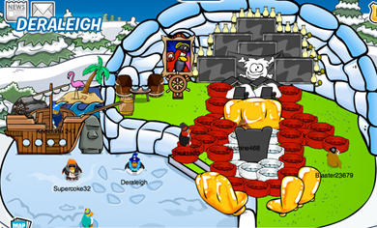[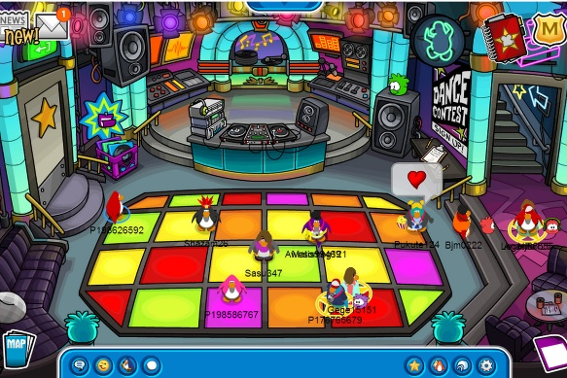](https://www.theverge.com/2013/2/20/4006014/online-dating-as-an-8-year-old)

Although architecture in games usually represents a sort of safe point for the player where they could maybe regain health or stock up on weapons it can also, as in the case with the dungeons in the Zelda series, be used to make the player feel lonely and anxious by placing the character in a colossal and bewildering building containing an overwhelming amount or small claustrophobic rooms filled with a creepy interior and nightmarish enemies for example huge spiders with skulls replacing their heads. Architecture can change a lot in a single game depending on where the character is for example in the Zelda series friendly towns and stables across the map are represented by homely straw thatch roofs and interiors what give off a comforting yellow glow from the warm stone fires in contrast if you are near enemy territory the architecture can change to the eerie dungeons I’ve previously discussed.

[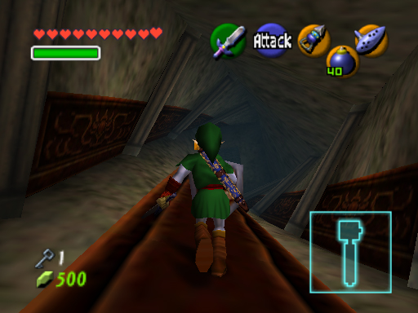](https://www.goombastomp.com/ocarina-of-time-dungeon-ranking/)[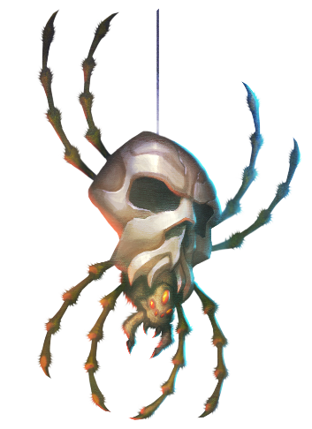](https://www.zeldadungeon.net/wiki/Skulltula)[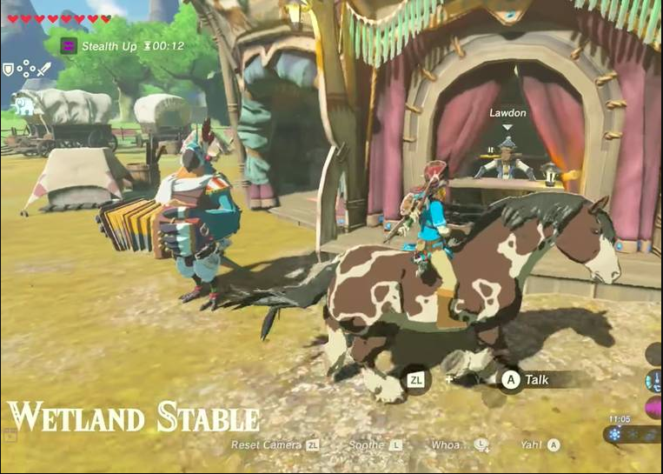](https://mic.com/articles/170400/zelda-breath-of-the-wild-stable-locations-8-horse-stables-to-save-on-your-map#.rnVDp8DPf)

# Objects

Objects in video games are items that the player can interact with for example a wooden box or a power up. In-game objects can be used in interesting ways especially in puzzle games such as portal where you have to move a box around in certain levels through lasers and mysterious goop while keeping the box intact and place it on weighted buttons to keep the exit door open to access the next level. Another example of interesting objects in video games is with the power up items/objects in Mario kart such as the classic banana which has multiple gameplay implementations to help you reach 1st place. With the banana you can defend by holding it on the back of your kart while driving to stop one of the enemies attacks, throw it at an enemy if you have good aim to immobilise them for a short time and finally you can drop the banana on the race track and hopefully have another competitor drive into it and slip.

[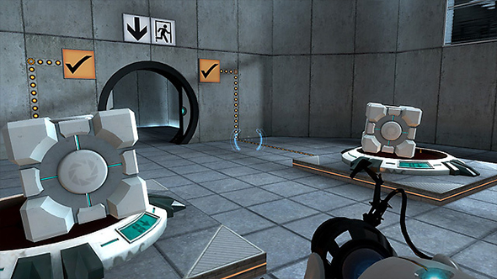](https://www.pcgamesn.com/portal/portal-orange-box-anniversary) [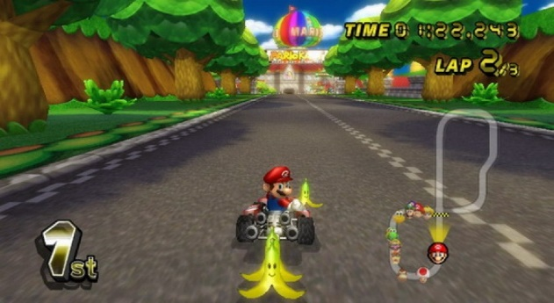](https://popcultureuncovered.com/2017/09/12/25-years-of-mario-kart-and-i-still-slip-on-the-bananas/)

# Character

Characters are the people you play as in a games story there are mainly two types of in game characters silent protagonists and ones that speak. Silent protagonists are usually used in video games for emersion as if you don't hear the character you play as speak you associate them with you as they are basically a blank slate for you to project yourself onto them. Whereas when a game has a protagonist that speaks the developers usually give the character more of a personality and backstory for example with the new Spiderman game on PS4 the character is given a lot of character development and story although they did have the comics to help them along. One thing I also liked about the game is the quirky quips Spiderman says while fighting enemies or traversing the map which I think really ground the character that while he is facing hardship he can still make jokes to deal with his problems. I think both methods can be executed really well therefore I don't really have a bias to either one as long as it's what the developer wanted the character to be I am happy in playing the developers envision of their character.

[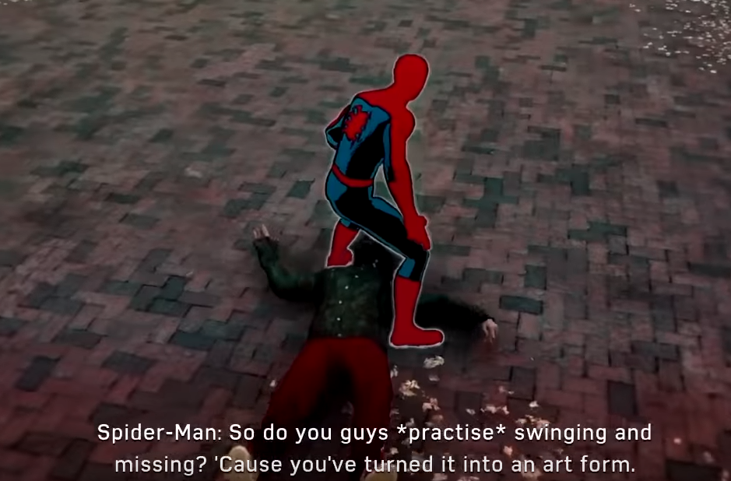](https://www.youtube.com/watch?v=E9ADwiwg39Y)

# NPC

NPC stands for Non-player character and they are the characters in a game that you interact with that are not controlled by another player. NPC’s usually give the player information, quests/tasks or sell the player in-game items to help the player on their journey. NPC’s can be really interesting depending on what the game developers do with their character as you can give the NPC a lot of in depth back story that can engross the player in their story. An example of this is with the character Kawakami in the JRPG Persona 5, in the game you play as a high school student in Japan, Kawakami is your form teacher which at first dislikes you as you play as a misunderstood delinquent but slowly opens up to you and offers after school revision sessions to help you catch up with your studies. During these sessions you learn that Kawakami used to be a bright and hopeful teacher compared to her current dreary self. However this all changed when in the past Kawakami had to privately tutor a student to stop him from being expelled, although things were looking up for the student he later ended up dying in a car crash. Due to this the students despicable relatives blamed the accident on Kawakami with the excuse of him being exhausted from the constant studying even though he had to work multiple jobs to live on his own as his relatives didn’t care for him. Now the relatives ask for bribes off of Kawakami to stop them from suing, because of this Kawakami now has to work at all hours of the day and is depressed from the degrading work and the student’s death. This NPC’s backstory engrossed me into the game as I wanted to help Kawakami get out of her horrible situation.

[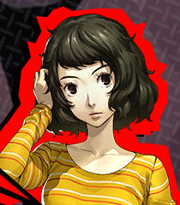](https://www.behindthevoiceactors.com/video-games/Shin-Megami-Tensei-Persona-5/Sadayo-Kawakami/) [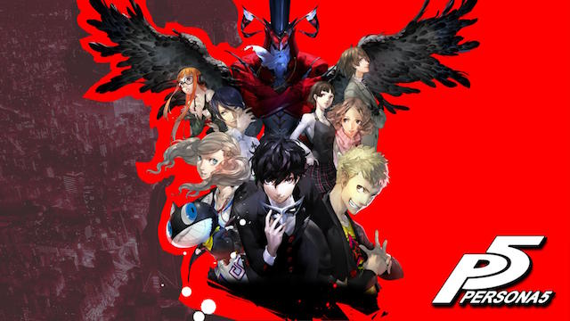](https://www.trustedreviews.com/reviews/persona-5)

<https://megamitensei.fandom.com/wiki/Sadayo_Kawakami>

# Feedback

Controller feedback can be a really useful tool for game developers to have the game communicate to the player informing them quickly by having the controller vibrate. Vibrations through the controller can also help immerse the player making them feel like the character on screen. An example of controller feedback used well in a video game is with Celeste a difficult platformer, in Celeste the controller vibrates when your character runs out of jumps quickly informing the player. Celeste also has the controller vibrate when the player dies for example by falling on a pit of spikes immersing the player to make them believe they are that character.

[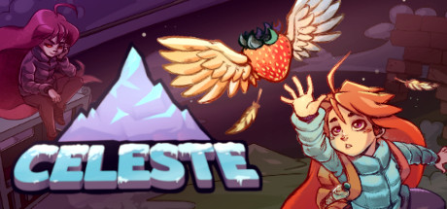](https://store.steampowered.com/app/504230/Celeste/)

Another form of feedback the player can experience is sound that can be used to reward or punish the player an example of sound being used to reward a player is in the game Zelda: Orcarina of Time, in this game whenever you open a chest you are awarded with a delightful tune as well as a useful in-game object such as a compass or arrows. However sound can also be used to punish the player for example with the classic game over tunes you hear over and over again every time you die making your brain associate the tune too losing making it so when you die you are immediately met with disappointment from the annoying jingle. Although the game over jingles are annoying I believe the most hated game over sound effect comes from the horror-survival game Five Nights at Freddie’s which has a robot scream at you before you die, now this would be ok if you heard it once but since the game is difficult and you die constantly while playing you will hear this screech so many times that you begin too deeply hate dying within the game.

[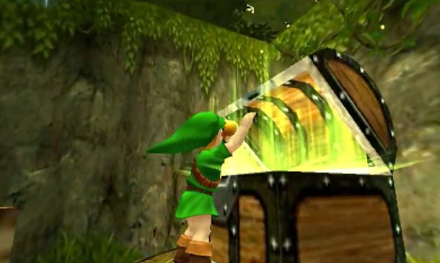](https://www.gameinformer.com/b/features/archive/2013/12/25/the-best-chest-openings.aspx) [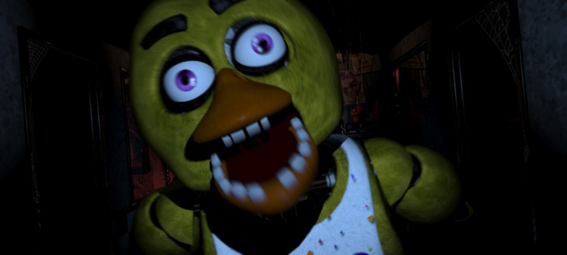](https://marketplace.secondlife.com/p/DeRpsAuRuS-FNaF-SCREAM-bumper/6441765?id=6441765&slug=DeRpsAuRuS-FNaF-SCREAM-bumper)

# Interface

Video game interfaces are usually similar to one another as having useful things like a mini map in the same place is really convenient for the layer as their muscle memory will make them instinctively look at the top left for directions or to see other players. The most common video game interface is a head up Display or more commonly known as a HUD this is a method of giving the user information about the character or game through images on the screen such as in the game Counter-Strike: Global Offensive. The reason it is called the HUD is because they are similar to the head-up up displays used in modern aircrafts. Personally I prefer video game HUD’s which are small as they don’t cause distractions and cover up an eighth of the screen like most.

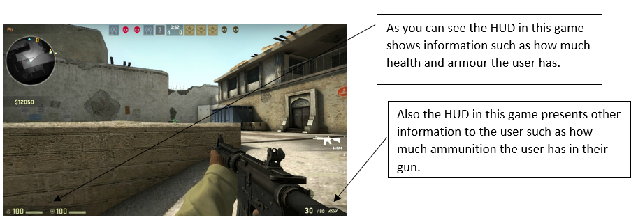

# Perspective

Perspective is a very important aspect of video games as it is how the player will view your game throughout the entire play through so you have to make sure the perspective the player is in integrates well with the gameplay. An example of this is with the top down strategy game Mario + Rabbids Kingdom Battle. The perspective means you have to play on a more strategic level than the immersion of a FPS shooter because when playing a game with the top down perspective you can usually see the whole level at all times so you have to think about where you are going to move your character and predict where the enemies will move. Whereas with an FPS you can only see what your eyes would be able to in real life making it more immersive. Personally I prefer playing games in the third person perspective as you get equally the same amount of emersion as you would playing in first person however you also get the strategic elements of the top down perspective as you can see further and behind you in third person.

[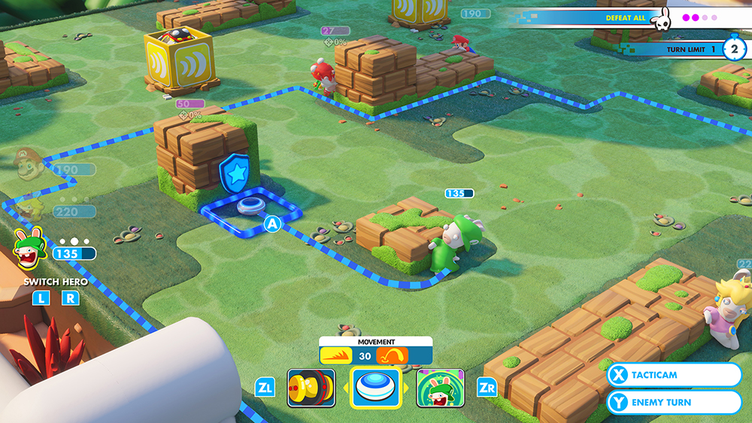](https://www.ebgames.ca/Switch/Games/732738)

# FMV (Full Motion Video)

FMV stands for full motion video and they are primarily used in video games to further the story. However sometimes they are used to also add comic relief to the game for example with Mario and Rabbids Kingdom Battles which uses FMV’s after boss battles to break the tension by having one of the Rabbids do something dumb such as when the Rabbid version of Peach insults the real peach’s dress even though they look exactly the same. Personally I prefer it when FMV’s focus more on character building rather than plot progression as it makes you like the characters you are playing as more.

[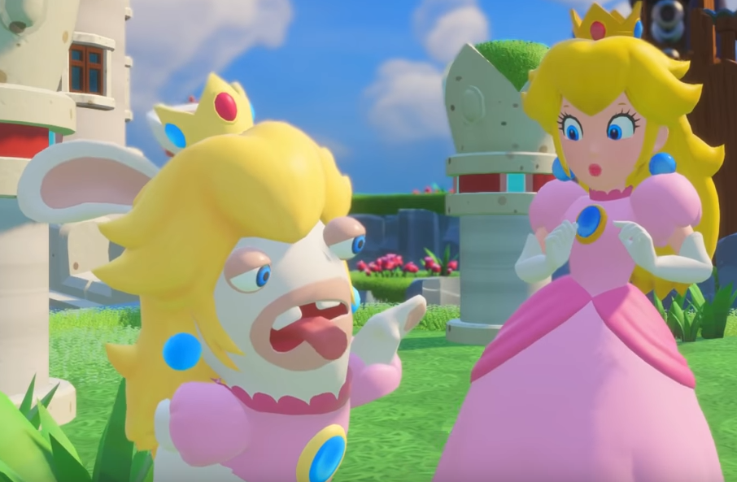](https://www.youtube.com/watch?v=J9sZ1kcr1GU&t=722s)

# Action

The action genre is very broad as nearly every game contains action based content as that is personally what I think makes games fun. However when most people think action they correlate it to first person shooters such as the  call of duty franchise that have you running around a map shooting and blowing up other players online. In my opinion I think action games like call of duty and the battlefield series go down the same line as racing games where they aim for realism in games rather that innovative mechanics meaning every new iteration in the franchise looks very similar to one another as hardly anything has changed except for the more realistic facial features etc. That's why I prefer more innovative action games such as Splatoon developed by Nintendo as an original IP, in the game you play as an inkling which can stay as a human like form and then can turn into a squid which can swim in the ink you shoot. The aim of the game is to shoot your team colours ink across the map while also killing the enemy team by dousing them with your ink. This is different to every other popular action game as if you compare it to a more realistic game such as Call of Duty: WW2 which is based on the events of World War 2 you will see. In Call of Duty you shoot bullets and the aim of the game is to kill your opponent whereas, in Splatoon you shoot out ink and the main objective in the game is to get the most amount of turf.

[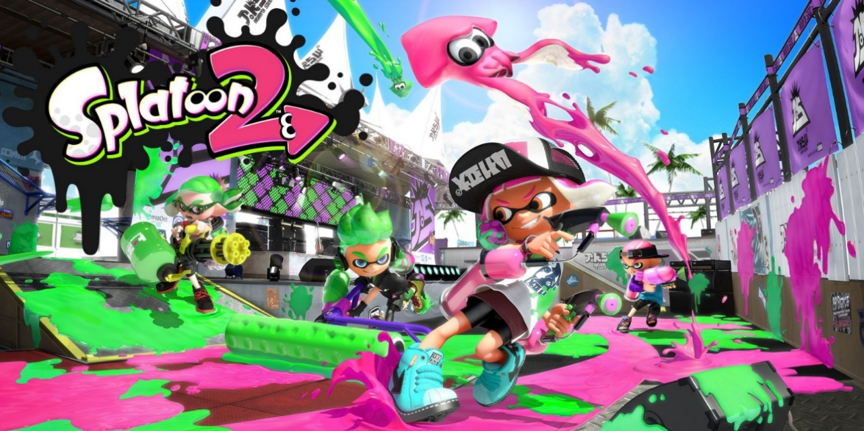](https://www.nintendo.co.uk/Games/Nintendo-Switch/Splatoon-2-1173295.html)

# Racing Games

Car racing games were some of the very first video games as they integrated well within the gaming genre as they were simple to program and provide art and game mechanics for as there is a lot of reference to go off. Racing games have always sold well as they are invigorating and fun to play. There have been many iterations or racing games however now they usually just come under two categories photorealistic simulation or animated fun to play. The main games that define the photorealistic racing simulation are Forza, Gran Turismo and Need for Speed each game is very similar to look at as they all aim to be the same thing the most realistic car game because of this I find this genre to be rather boring as they focus on realism over playability. On the other hand the fun to play racing games aim for a more mechanically diverse game over graphics and each have their own unique art style for example Mario Kart and Rocket League. In Rocket League you control a car which can rocket itself into the air and play football.

[](https://www.forzamotorsport.net/en-us/)[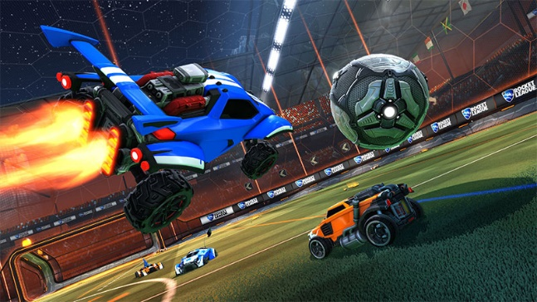](https://store.steampowered.com/app/252950/Rocket_League/)

# Sports Games

Sport games also have a split between realism and fantasy as you have Fifa which aims for each iteration in the series to be more realistic and as close to the current sport as it can get by updating the rules, top players and teams with real world football. On the other hand you have games such as Mario Strikers which is also a game revolving around the football sport however in this game the character roster is made up of only Nintendo’s creations. Mario Strikers also bends some of the sports rules by being able to aggressively tackle every player on the pitch with your super powered kicks that set on fire creating a fun and chaotic game. Personally I prefer playing the fun fantasy sports games as if I wanted realism I would just play the sport in real life and have a more immersive experience.

[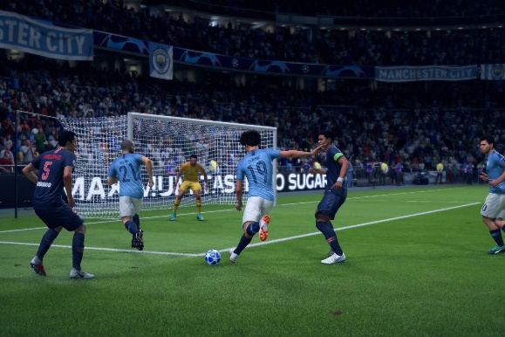](https://www.redbull.com/int-en/most-improved-players-fifa-19)[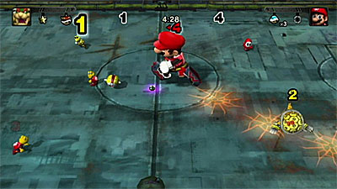](https://www.cheatcc.com/wii/rev/mariostrikerschargedpreview.html)

# Survival Horror Games

The survival horror genre have gained popularity in recent years with games such as don't starve, the forest and the last of us. Although the sub-genre used to be split and the two genres would not mix frequently they were still very popular genres in their own right as proven with the popular horror game FNAF and the even more popular survival game Minecraft. However the two genres integrate well with each other as when put with the task of surviving by collecting resources to live the risk of death from horrifying monsters is perfect motivation to stay alive and progress through the game. A perfect example of this is with the extremely difficult don't starve in this game you have to spend your time well when there is day light by collecting food and items to build a fire as at night shadow monsters will come to devour you and extinguish your fire, this is perfect motivation to keep collecting resources as if your character gets hungry or takes damage their sanity will go down which makes the monsters a greater threat as they will get stronger the lower your sanity drops and will eventually start appearing in the day.

[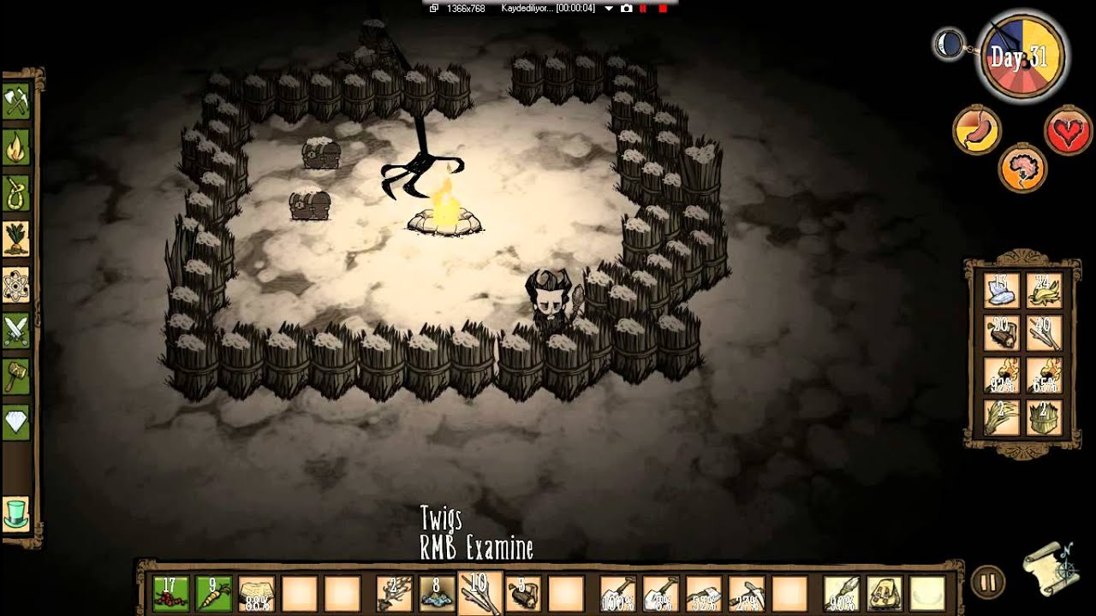](https://www.youtube.com/watch?v=ukSzKCekJUg)

# Third & First Person Shooters

Third person shooter games are currently widely popular with games like GTA (Grand Theft Auto) and Tom Clancy the division, with the third person camera angle it allows the player to both be immersed and have the vision to see players/enemies behind you. First person games have always been popular both for multiplayer such as the call of duty franchise and single player games. However I believe first person shooters are best suited for single player, for example with the games series Half Life because it is set in first person it allows the players to be truly immersed and associate themselves with the character thy as playing as because they experience the game seeing through their eyes. Between first person and third person shooters I prefer the latter because I like being able to see what is happening around my character and for me I still find it to be immersive.

[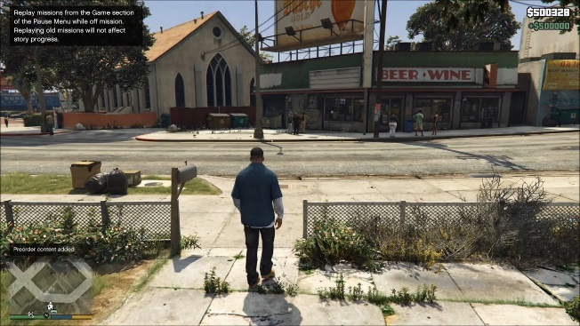](https://www.youtube.com/watch?v=d74REG039Dk)[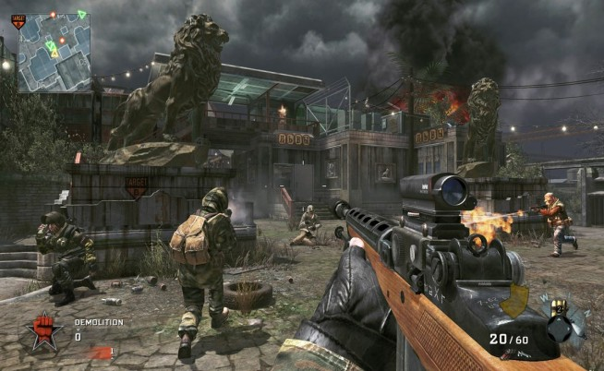](https://mp1st.com/news/is-call-of-duty-better-without-kdr-cod-gameplay-designer-answers)

# Puzzle Games

Puzzle games have always been popular as there is just something so fun about rattling your brain trying to figure out a solution too something. Puzzle games used to only be played on desktop computers since they could only run on that device at the time, however nowadays puzzle games have shifted to portable devices such as mobile phones which I personally believe is what they are best suited too. An example of a two similar puzzle games is with Bejewelled and Candy Crush both being connect three games, Bejewelled used to be more popular but now with the rise of smartphones and Candy Crush having the superior app Bejewelled has been dethroned. This reason for this is because Candy Crush is a smartphone game and puzzle games do well on portable devices because players are able to pausing and come back anytime they want throughout the day once their brain has found the solution whereas if it was on a desktop computer like bejewelled mainly is you would only get to play it once or twice per day in continuous play not giving your brain time to rest.

[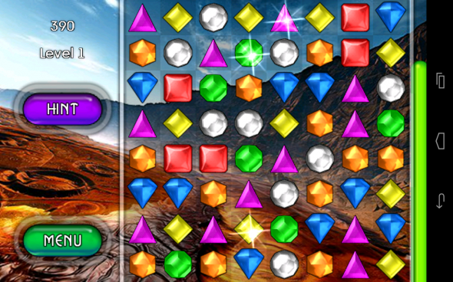](https://www.geek.com/games/awesomely-addictive-games-like-candy-crush-saga-1553688/) [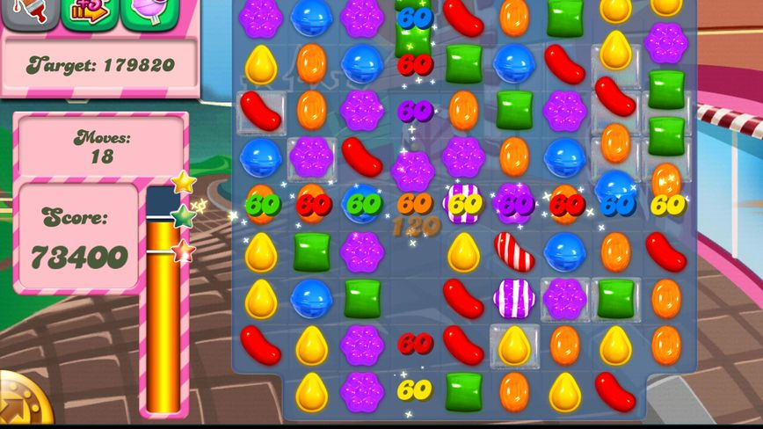](https://www.cnet.com/reviews/candy-crush-saga-android-review/)

# Management Games

Management games are aimed at the more Tyrannical player as they escape their own life and control others for example in the Sims where you are able to (another word for control) an NPC’S life and drag them around the city to say go to the gym and then into a nightclub while still smelling of sweat to make the sim embarrassed. Other types of management games focus less on one NPC and have you build a massive structure and then manage the people inside as a whole, an example of this is with the game Prison Architecture where you design and build a prison and then manage the inmates and workers inside. This game is clearly built for their target audience as a feature in the game allows you to design your own inmates to place in your prison for example the player’s school bully Roger is now trapped in solitary for the rest of his sentence. Personally I do enjoy some management games but I think in the later part of the game it gets too complicated with the addition of more and more problems that you have to fix that's why I prefer watching other people play them as I don't have to start stressing out in the later game with the massive spike in difficulty for example in the sims you could start off as controlling one person but then they start a family and you are suddenly controlling three people at once.

[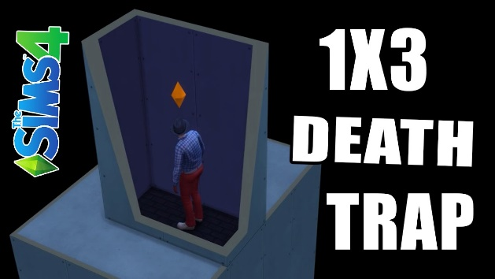](https://www.youtube.com/watch?v=MHcPeHGrRNk) [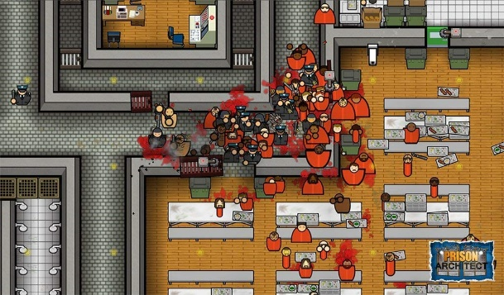](https://www.amazon.co.uk/Sold-Out-215391-Prison-Architect/dp/B01ER780GC)

# Educational Games

Educational games are quite rare currently as the public have subconsciously agreed that educational games are not fun and not that beneficial and the best way to learn is still with textbooks and working out on paper. However there are still businesses trying to keep the market alive and sell educational tablets to parents for their toddlers. The most well-known educational tablet is the Leapfrog which has children perform simple math equations and spelling as their favourite Disney character cheers them along with a happy theme tune.

[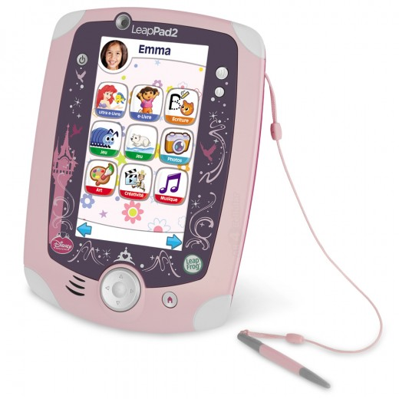](https://www.a4c.com/product/leapfrog-leappad-2-explorer-kids-learning-tablet-disney-princess-refurbished.html)[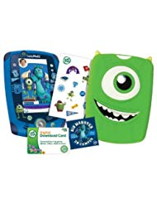](https://www.mydearbooks.com/book-leappad-2-game-cartridge.html)

One of the most notable educational games was Brain Training for the DS which had people solve easy math equations to hard ones quickly in a small time frame. This game was so influential it had schools start buying the systems with the game installed allow wing children to play this in class. Personally I think this game was flawed as it would never recognise my hand writing as I tried my best the write a four with the slippery stylus. Although the game to me was bad I think the worst offender in the educational game craze that started with brain training was the schools that thought a £200 toy would teach children better than their qualified teachers.

[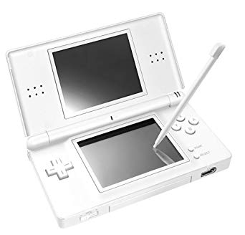](https://www.amazon.co.uk/Nintendo-Lite-Handheld-Console-White/dp/B000EZSFQM)[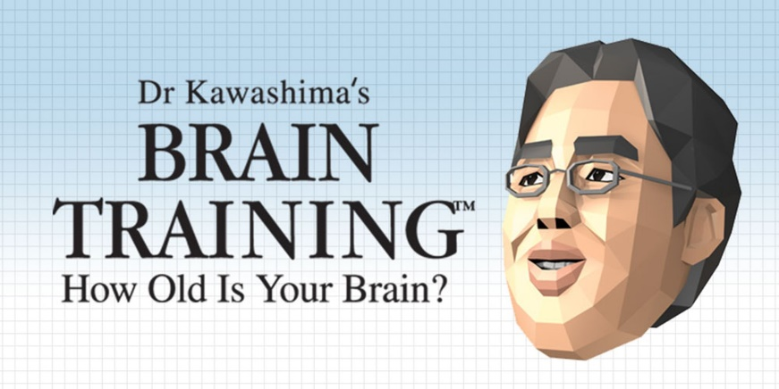](https://www.nintendo.co.uk/Games/Nintendo-DS/Dr-Kawashima-s-Brain-Training-How-Old-is-Your-Brain--270627.html)

# Simulation Games

Simulation games never really have that much story as the player is usually dropped into a random scenario and are put to work. For example, in the game Super-Hot it starts off with someone charging towards you with a knife and that is it once you defeat the charging enemy you are dropped off in front of two enemies and then the game continues to escalate.

[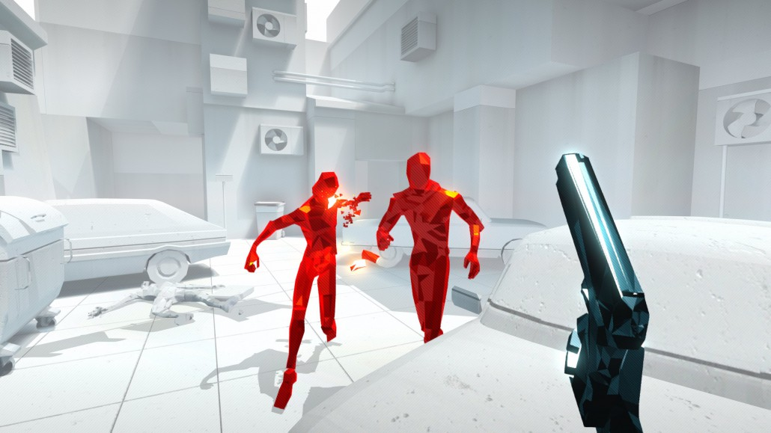](https://superhotgame.com/)

An example of a simulation game which has a story is Abzu it is a swimming simulator made for Virtual Reality (VR) the general concept of the story is that you are an adventurer who has always had a dream of diving into the depths of the ocean and finding new sea life.

# Fighting Games

Fighting games involve the player fighting another character by using certain button combination to defeat their opponents by using special moves. The story usually isn’t very detailed in fighting games for example with Mortal Kombat there used to be no story in the games and you just started by selecting a character and then killing your opponent. Whereas, in Super Smash Bros Brawl there is a story mode where you fight your way through hordes of enemies to turn your friends back from trophies.

[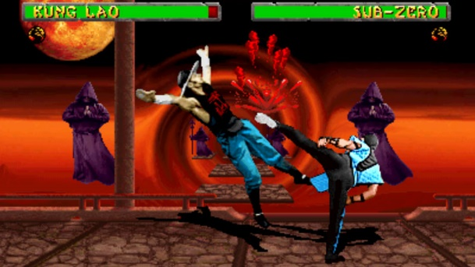](https://www.engadget.com/2007/04/11/mortal-kombat-ii-gets-downloadable-april-12th/)[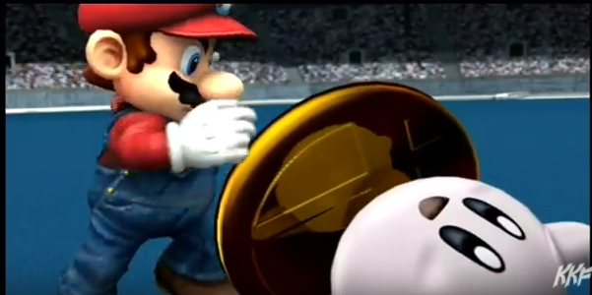](https://www.youtube.com/watch?v=7Xg-sx9YxRo)

# Role Playing Games (RPG)

Role Playing Games are games that involve the player taking on a role of a fictional character usually in a science-fiction setting an example of this is Pokémon where you play as a young boy or girl and catch, and train pocket monsters called Pokémon. Pokémon is a game series not really known for their story but more for the gameplay whereas Persona 5 is widely known for its great story and music rather than its gameplay so much so that it was recommended for game of the year.

[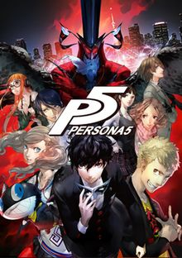](https://en.wikipedia.org/wiki/Persona_5)[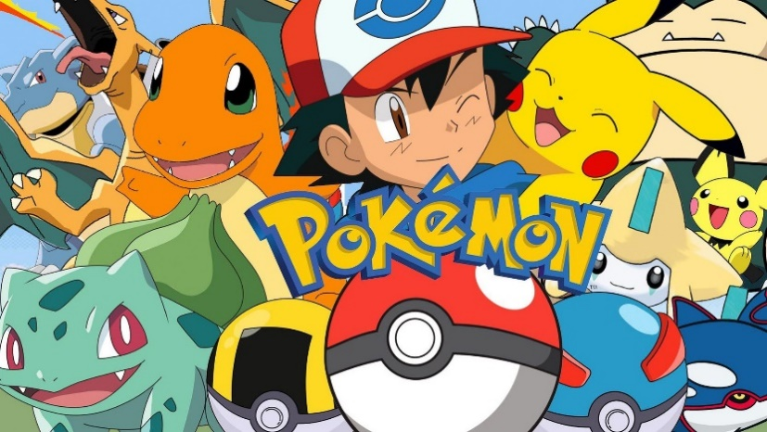](http://www.clubit.tv/2017/08/pokemon-movie-western-release/)